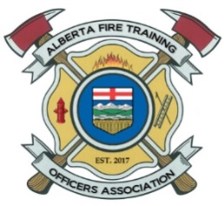
AFTOA NOMINATION FORM
Alberta Fire Training Officers Association
P.O. Box 2603 Stony Plain, AB T7Z-1Y2
Email: abfiretrainingofficers@gmail.com

POSITION:
Indicate the position of nomination and the zone you reside within.
Nomination Date: |  |  |  | MM/DD/YYYY
Position: President 1st Vice 2nd Vice Secretary Treasurer Zone Rep Alternate Rep
AFTOA Zone: North Central South
Department:
APPLICANT PERSONAL INFORMATION:
Full Name:
Last |  |  |  |  |  |  |  | First |  |  |  | M.I.
Address:
Street Address |  |  |  |  |  |  |  |  |  |  |  | Apartment/Unit #
Town/City/County |  |  |  |  |  |  |  |  |  | Province |  | Postal Code
Home Phone: |  | ( ) |  |  | Alternate Phone: |  |  |  | ( )
E-mail Address:
EXPERIENCE:
List any relevant experience for the position. This will be listed on the candidate’s bio on the member only section when nominations are closed. (Attach additional sheet if required).
Training:
Fire Service-Work :
Committee/Other:

AUTHORIZATION/DECLARATION:
By submitting this application I am formally offering my name for nomination for the position indicated above with the AFTOA. I have read and understand both the bylaws of the association and Operational Guidelines for the position, am a member in good standing, and have the support of my organization for the above position.
Applicant signature: |  |  |  |  |  |  | Date:

